Rapport :
TP03 :

Ex 2:

#include <iostream>

using namespace std;

class point
{
float x, y;
static int n;

public:
point(float, float);
~point();
void display();
};

int point ::n = 0;

point ::point(float a = 0, float b = 0)
{
cout << "You Have Got " << ++n << " Points " << endl;
x = a;
y = b;
}

point ::~point()
{
cout << "You Still Have Got " << --n << " Points " << endl;
}

void point::display()
{
cout << "(" << x << "," << y << ") \nYou Have Got " << n << " Points " << endl;
}

int main()
{
point *tab = new point[4];
for (int i = 0; i < 4; i++)
{
tab[i].display();
}
delete[] tab;
return 0;
}

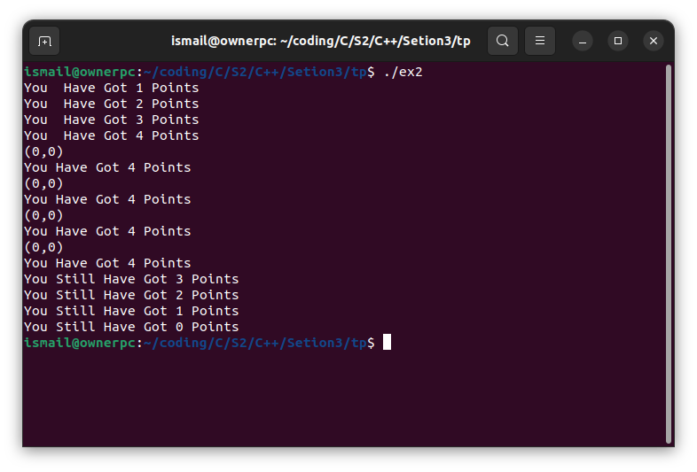

Ex 3:

#include <iostream>
using namespace std;

class set_int
{
int N;
int *tab;
int max;

public:
set_int(int);
set_int(set_int &);
~set_int();
int appartient(int);
void ajouter(int);
int car();
void display();
};

set_int ::set_int(int a = 20)
{
max = a;
N = 0;
tab = new int[max];
}

set_int ::~set_int() { delete[] tab; }

set_int ::set_int(set_int &A)
{
A.max = max;
A.N = N;
tab = new int[max];
for (int i = 0; i < max; i++)
{
tab[i] = A.tab[i];
}
}

int set_int::appartient(int a)
{
int k = 0;
for (int i = 0; i < N; i++)
{
if (tab[i] == a)
{
return ++k;
}
}
return k;
}

void set_int::ajouter(int a)
{
if (N == max)
{
cout << "Your arr is full" << endl;
}
else
{
if(this->appartient(a) == 0)
{
tab[N] = a;
N++;
}
else {
cout << "Number is already in the arr" << endl;
}
}
}

int set_int :: car(){
return N;
}

void set_int ::display(){
cout << "THis Is The Full Arr" << endl;
for (int i = 0; i < N; i++)
{
cout << "Elemeent Number " << i << " is : " << tab[i] << endl;
}
}

int main()
{
int n;
cout << "Give the max : " << endl;
cin >> n;
set_int A(n);

int number;

cout << "donner le nombre d'elemenets que vous voulez siasir " << endl;
cin >> number;
int element;

for (int i = 0; i < number; i++)
{
cout << "Element number " << i << " : " << endl;
cin >> element;
A.ajouter(element);
}

int found;

cout << "Donnez l'elemeent a cherche : " << endl;
cin >> found;

if (A.appartient(found) == 1)
{
cout << found <<" appartient" << endl;
}
else
{
cout << found << " non appartient" << endl;
}

cout << "Number of elements is " << A.car() << endl;

cout << "Give a number to the arr : " << endl;
cin >> element;

A.ajouter(element);
A.display();
return 0;
}

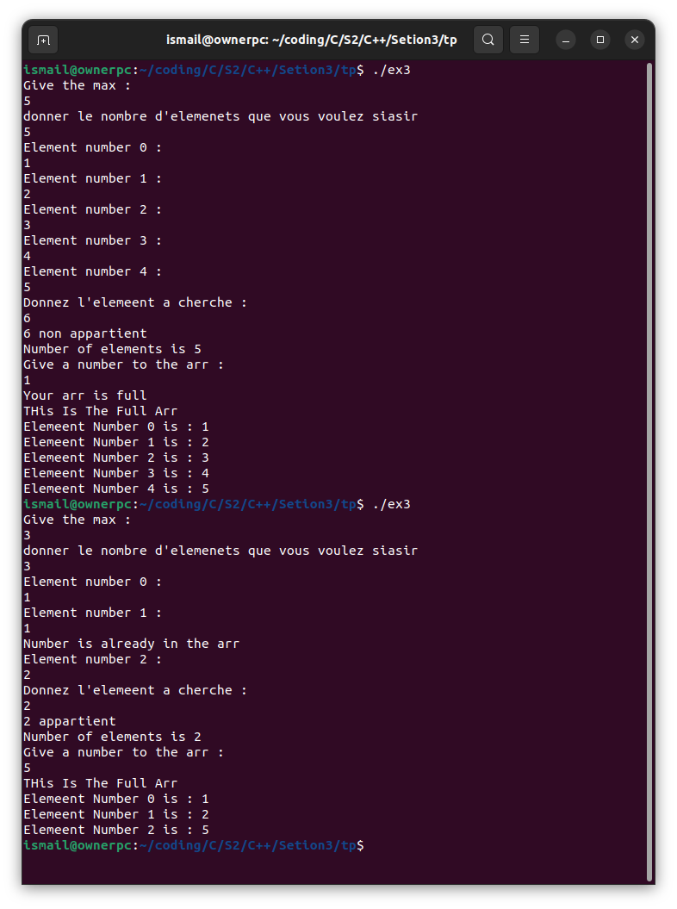

Ex 4:
#include <iostream>
using namespace std;

class set_int
{
struct node
{
int data;
node *next;
node(int data = 0, node *next = nullptr) : data(data), next(next) {}
};
node *head;
int N;

public:
set_int();
set_int(set_int &);
~set_int();
int appartient(int);
void ajouter(int);
int car();
void display();
};

set_int::set_int()
{
head = nullptr;
N = 0;
}

set_int::~set_int()
{
node *temp = head;
while (head != nullptr)
{
head = head->next;
delete temp;
temp = head;
}
}

set_int::set_int(set_int &A)
{
head = nullptr;
N = A.N;
node *temp = A.head;
while (temp != nullptr)
{
ajouter(temp->data);
temp = temp->next;
}
}

int set_int::appartient(int a)
{
int k = 0;
node *temp = head;
while (temp != nullptr)
{
if (temp->data == a)
{
k++;
}
temp = temp->next;
}
return k;
}

void set_int::ajouter(int a)
{
if (appartient(a) == 0)
{
node *temp = new node(a);
temp->next = head;
head = temp;
N++;
}
else
{
cout << "Number is already in the list" << endl;
}
}

int set_int::car()
{
return N;
}

void set_int::display()
{
cout << "This is the full list" << endl;
node *temp = head;
while (temp != nullptr)
{
cout << "Element is: " << temp->data << endl;
temp = temp->next;
}
}

int main()
{
set_int A;

int number;
cout << "How many elements do you want to add?" << endl;
cin >> number;
int element;
for (int i = 0; i < number; i++)
{
cout << "Element number " << i << ": ";
cin >> element;
A.ajouter(element);
}

int found;
cout << "Enter the element you want to search for: ";
cin >> found;
if (A.appartient(found) == 1)
{
cout << found << " is in the list" << endl;
}
else
{
cout << found << " is not in the list" << endl;
}

cout << "Number of elements is " << A.car() << endl;

cout << "Enter a number to add to the list: ";
cin >> element;
A.ajouter(element);
A.display();
return 0;
}

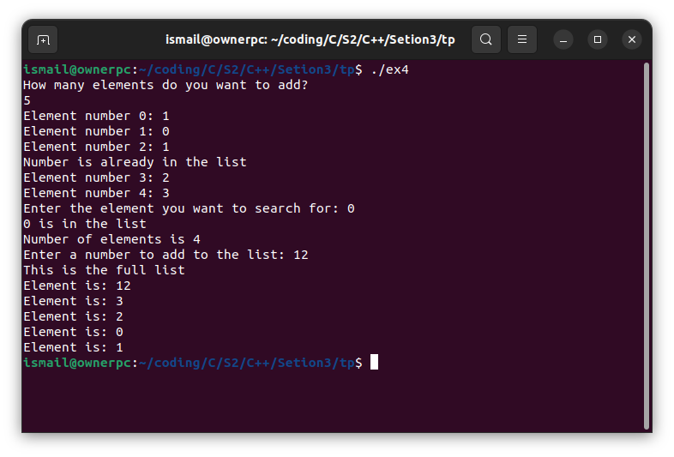

TP04 :

Ex 1:

#include <iostream>
#include <cmath>
using namespace std;

class comp
{
float Re;
float Img;

public:
comp(float, float);
void display();
float module();
comp conjugue();
comp operator+(comp);
comp operator+(double);
comp operator*(comp);
comp operator*(double);
};

comp ::comp(float x = 0, float y = 0)
{
Re = x;
Img = y;
}

float comp ::module() { return sqrt(Re * Re + Img * Img); }

comp comp ::conjugue()
{
comp test;
test.Re = Re;
test.Img = -Img;
return test;
}

comp comp ::operator+(const comp temp)
{
comp test;
test.Re = Re + temp.Re;
test.Img = Img + temp.Img;
return test;
}

comp comp ::operator+(double temp)
{
comp test;
test.Re = Re + temp;
test.Img = Img;
return test;
}

comp comp ::operator*(const comp temp)
{
comp test;
test.Re = (Re * temp.Re) - (Img * temp.Img);
test.Img = (Re * temp.Img) + (Img * temp.Re);
return test;
}

comp comp ::operator*(double temp)
{
comp test;
test.Re = Re * temp;
test.Img = Img * temp;
return test;
}

void comp ::display() { cout << "This Is Your Number (" << Re << " + (" << Img << ")i) ;" << endl; }

int main()
{
comp A;
A.display();
comp B(5, 9);
B.display();
double num = 10;

cout << "The Modelu of your point is : " << A.module() << endl;
cout << "The Modelu of your point is : " << B.module() << endl;

cout << "The Conjugue of your point is : " << endl;
(B.conjugue()).display();

cout << " A + B = " << endl;

(A + B).display();

cout << " A + Num = " << endl;

(A + num).display();

cout << " A * B = " << endl;

(A * B).display();

cout << " A * Num = " << endl;

(A * num).display();

return 0;
}

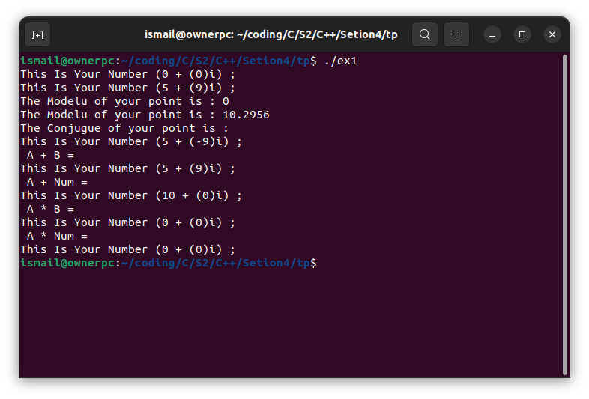

Ex 2:

#include <iostream>
#include <cstring>
using namespace std;

class chaine
{
int length;
char *name;

public:
chaine();
chaine(const char *);
chaine(chaine &);
chaine operator=(chaine);
int operator==(chaine);
chaine operator+(chaine);
char operator[](int);
void display();
};

chaine::chaine()
{
name = nullptr;
length = 0;
}

chaine::chaine(const char *ptr)
{
length = strlen(ptr);
name = new char[length + 1];
strcpy(name, ptr);
}

chaine::chaine(chaine &ptr)
{
length = ptr.length;
name = new char[length + 1];
strcpy(name, ptr.name);
}

chaine chaine::operator=(chaine ptr)
{
length = ptr.length;
name = new char[length + 1];
strcpy(name, ptr.name);
return *this;
}

int chaine::operator==(chaine ptr)
{
if (length != ptr.length)
return 0;
for (int i = 0; i < length; i++)
{
if (name[i] != ptr[i])
return 0;
}
return 1;
}

chaine chaine::operator+(chaine ptr)
{
chaine temp;
temp.length = length + ptr.length;
temp.name = new char[temp.length + 1];
strcpy(temp.name, name);
strcat(temp.name, ptr.name);
return temp;
}

char chaine::operator[](int i)
{
return name[i];
}

void chaine:: display(){
cout << "This The String : " <<name << endl;
}

int main()
{
chaine str1("Hello,");
chaine str2(" World!");
chaine str3;

str3 = str1 + str2;

str3.display();

if (str1 == str2)
cout << "str1 is equal to str2" << endl;
else
cout << "str1 is not equal to str2" << endl;

if (str3 == str3)
cout << "str1 is equal to str3" << endl;
else
cout << "str1 is not equal to str3" << endl;

cout << str3[0] << endl;

return 0;
}

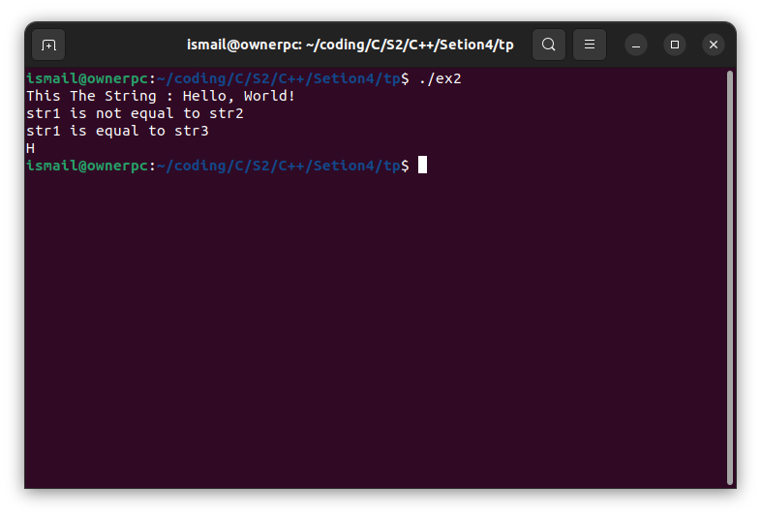
Exemples de cours :

Exp 1:

#include <iostream>
using namespace std;

class point
{
float x, y;

public:
friend point operator+(point, point);
point(float, float);
void display();
};

point :: point (float a = 0, float b =0){x = a;y = b;}

point operator+(point A, point B){
point temp;
temp.x = A.x + B.x;
temp.y = A.y + B.y;
return temp;
}

void point :: display(){
cout << "Coord Of Your Point : (" << x << "," << y << ") " << endl;
}

int main(){
point A(4, 3);
point B(10, 0);
A.display();
B.display();
(A+B).display();

return 0;
}

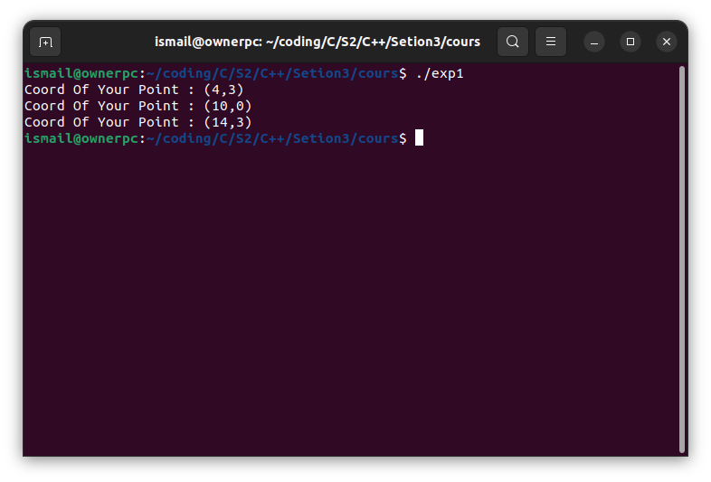

Exp 2:

#include <iostream>
using namespace std;

class vecteur3d
{
float x, y, z;

public:
vecteur3d(float, float, float);
void display();
friend int operator==(vecteur3d, vecteur3d);
friend int operator!=(vecteur3d, vecteur3d);
friend float operator*(vecteur3d, vecteur3d);
};

vecteur3d::vecteur3d(float a=0, float b=0, float c=0){
x=a; y=b; z=c;
}

int operator==(vecteur3d A, vecteur3d B){
return A.x == B.x && A.y == B.y && A.z == B.z;
}

int operator!=(vecteur3d A, vecteur3d B)
{
return !(A == B);
}

float operator*(vecteur3d A, vecteur3d B){
return A.x*B.x + A.y*B.y + A.z*B.z;
}

void vecteur3d:: display(){
cout << "Coord Of Your Point : (" << x << "," << y << "," << z << ")"<< endl;
}

int main()
{
vecteur3d v1(1, 2, 3);
vecteur3d v2(4, 5, 6);

v1.display();
v2.display();

if (v1 == v2)
{
cout << "v1 is equal to v2" << endl;
}
else
{
cout << "v1 is not equal to v2" << endl;
}

if (v1 != v2)
{
cout << "v1 is not equal to v2" << endl;
}
else
{
cout << "v1 is equal to v2" << endl;
}

float dotProduct = v1 * v2;
cout << "Dot product of v1 and v2 is: " << dotProduct << endl;

return 0;
}

